|  |
| --- |
| SYI Games |
| 2D_YRunner_Platformer_300857600 |
| **2D Platformer Maniacs** |
| Version #0.6.1  All work Copyright © 2015 by SYI Games.  All rights reserved. |
| **[Sangbeom Yi; 300857600]** |
|  |

**Logo.png**

|  |
| --- |
| October 5, 2015 |

**Table of Contents**

[Your Table of Contents should go here. Make sure that your document’s sections are hyperlinked to their corresponding pages.]

**# GitHub**  
https://github.com/SeanSBYi/2D_YRunner_Platformer_300857600

**#eCentennial Dropbox**

**Version History**

--------------------------------------------------------------------------------

All Source code has each version History

|  |
| --- |
| Cap 2015-10-26 06-00-46-659.png |
| Cap 2015-10-26 06-00-40-563.png |

--------------------------------------------------------------------------------

Version 0.1.0  
Create default Camera, Player, Enemy  
Scroll Background

Version 0.2.0  
 Random Ground Scroll

Version 0.3.0  
Get the Coin

Version 0.4.0  
Add Sound Resource

Version 0.5.0  
Game Over and High Score

Version 0.6.0  
Add Intro Scene

Version 0.6.1  
Minor Balance Patch

-----------------------------------------------------------------------------------------

1. **Game Overview**

*Just Run and Run! You must survive and get the high score!*

1. **Game Play Mechanics**

*Just run and get the coin.*

1. **Camera**

*Fixed Camera View. 2D platformer Scroll action game.*

1. **Controls**

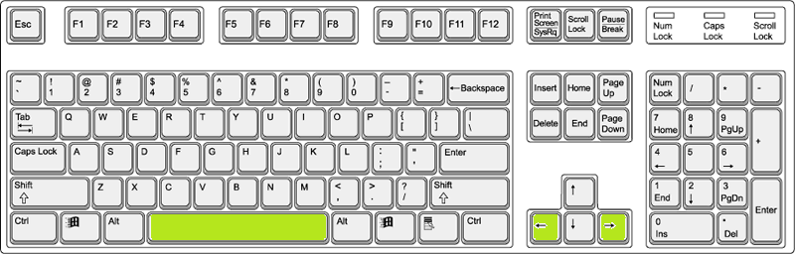

* *Left, Right : My Character move*
* *Space :My Character Jump*



* *Left Click : Select Menu (Click Button)*

1. **Saving and Loading**

*This game doesn’t support the save and load*

1. **Interface Sketch**

Distance 100m

Coin : 100

1. **Menu and Screen Descriptions**

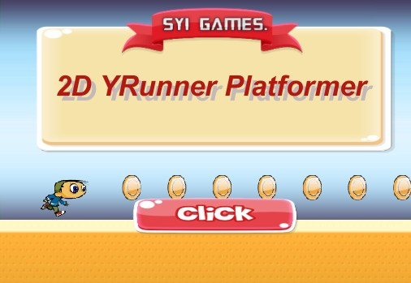

*[Title Screen]*

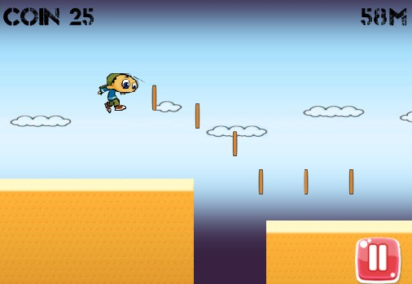

*[Main Game Screen]*

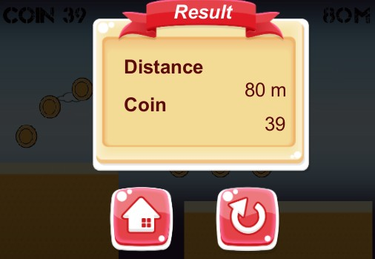

*[Result Menu Screen]*

1. **Game Progression, Levels**

*It is endless 2d scroll. Scroll speed will be fast. (4 sec)*

1. **Enemies, Non-player Characters**

*Version 0.8 Expected*

1. **Items**
2. *Coin (Score Item)*
3. *Speed Up (Version 0.9 Expected)*
4. *Double Jump*
5. **Scoring**

*Coin Point ( 1 coin is 1 point)*

*Distance Point*

1. **Resource Index**

*Sound*

*Effect:2D Platform Game Demo in the Class*

*Sound :*http://www.econovation.co.kr/ecnvb/%EA%B0%9C%EB%B0%9C%EC%9E%90-%EC%A7%80%EC%9B%90/%EC%98%A4%ED%94%88%EC%86%8C%EC%8A%A4/  
(Open Source, 3music-intro, main, result)

Image (Free Image)

http://www.gameart2d.com/free-game-gui.html

http://opengameart.org/content/free-ui-asset-pack-1

1. **Future Features**

*Playable Character*

*New Player Character*

*Add Enemy*

*New Design and Animation*

*Various Type of BG*

*New BG*

*Make a Stage System*

*Add New Item*

*Add New Ground*

*Trap*

*Moving Ground*

*New Platform  
 Unity Web Player, Mobile*